DevilPhysics
AP Physics

Name: __________________________________

Period: ________ Date: ___________________
Baddest Class on Campus
GIANCOLI READING ACTIVITY
Sections 10-8 to 10-10
- Read sections 10-8 to 10-10 in your textbook.
- Write a definition for each of the terms listed below:
  - fluid dynamics
  - hydrodynamics
  - streamline or laminar flow
  - turbulent flow
  - viscosity
  - mass flow rate
  - equation of continuity
  - Bernoulli’s principle
  - Bernoulli’s equation
  - Torricelli’s theorem
  - dynamic lift
  - venturi tube
- Answer the following questions:
  - What does the word “laminar” mean?
  - What is one factor that will cause streamline or laminar flow to become turbulent flow?
  - What do eddies do to the energy of a fluid flow?
  - Bonus: Name the TV shows in which these eddies were characters; Eddie Haskell, Eddie Munster, Eddie Winslow?
  - Assuming that a fluid is incompressible (i.e. density remains the same), what will happen if a fluid flows from a pipe with larger diameter to one with a smaller one and vice versa?
  - The aorta is a large artery that comes directly from the heart and capillaries are tiny vessels that bring blood to tissues in the extremeties. Blood flow in the capillaries is much slower than that in the aorta which is the exact opposite of the equation of continuity. How can you explain this?
  - Referring to figure 10-19, why wouldn’t there be higher pressure in Area 2 where the velocity is greater?
  - In Bernoulli’s equation [$P_{1}+1/2ρ{v_{1}}^{2}+ρgy_{1}=P_{2}+1/2ρ{v_{2}}^{2}+ρgy_{2}$], points 1 and 2 can be any two points in the fluid flow which means $P+1/2ρv^{2}+ρgy=constant$. What law does this fact illustrate?
  - Why does smoke flow up a chimney?
  - Why does fresh air blow through a prairie dog’s tunnel?

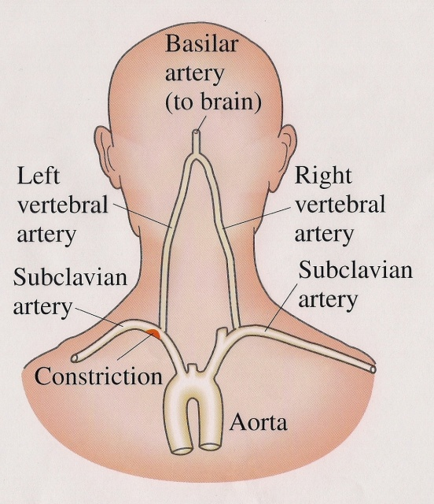
  - Use Bernoulli’s principle to explain why transient ischemic attacks occur.
  - What two things does Bernoulli’s equation ignore?
- This assignment may be typed or neatly printed. Drawings may be freehand, but try to make use of the ‘Shapes’ or ‘Insert Clipart” functions of MS Word. If you submit this assignment electronically, the filename must be in the following format, “LastnameFirstinitialPerXReadActX-X”. You do not need include a copy of these instructions with the assignment you hand in.

