***DevilPhysics***

***AP / IB Physics***

Name: __________________________________

Period: ________ Date: ___________________

***Baddest Class on Campus***

**OBJECTIVE:** To demonstrate your expertise in computing the path of an object in parabolic motion and to utilize your honed judgment in estimating the effects of air resistance . . . and to possibly earn a homework pass.

**BALL-IN-THE-CUP EXERCISE**

**Explorations Into Projectile Motion**

**PROCEDURE:**

NOTE: Since we only have one apparatus, table groups will have to take turns rotating through the procedure steps. Your teacher will give you the order of table groups.

|  |  |
| --- | --- |
| 1. You will be assigned either a golf ball or a steel ball to use for this experiment. Write down the type of ball used. |  |
| 1. Use a caliper to measure the diameter of your ball. |  |
| 1. Measure the distance from the bottom of the ramp to the floor. |  |
| 1. Conduct three trials to determine an average time it takes for the ball to pass through the photogate. |  |
| * 1. Trial 1 |  |
| * 1. Trial 2 |  |
| * 1. Trial 3 |  |
| * 1. Average |  |
| 1. Compute the horizontal velocity of the ball at the bottom of the ramp. Show your work below. |  |
| 1. Determine the horizontal distance your ball will travel. Show your work below. |  |
| 1. Place the cup at the distance computed in number 6 above. Make adjustments for air resistance, angle of entry, and height of the bottom of the cup above the floor. |  |
| 1. You have one shot to get the ball in the cup to earn a homework pass. If you fail to make it on the first try, you may make adjustments and take up to three more tries to enhance your self-esteem. |  |

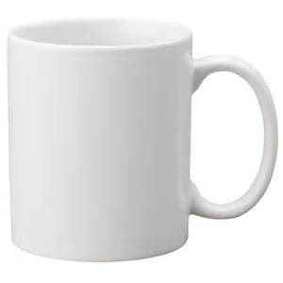***This certificate rewards the bearer with one Homework Pass to be used on the Reading Activity or Homework Assignment of their choice.***

***Name:***

***Assignment:***

***Teacher:***