DevilPhysics
AP Physics

Name: __________________________________

Period: ________ Date: ___________________
Baddest Class on Campus
EVEN MORE ACCELERATION LAB
(1/2 Point Each, 16 Points Total)
Part I. Elevator Physics (10pts) (with lab partner, lab partner name: )
Objective – During this portion of the lab you will determine the vertical accelerations in an elevator using a vertical accelerometer. You will also analyze the motion of an elevator.
Discussion – The net force on the mass in the accelerometer is given by the relationships: and , where is the force applied by the spring to the mass, and is the weight due to gravity of the mass. When the mass is at rest or moving with constant speed in an upward or downward direction, the upward pull of the spring is equal in magnitude to the downward pull of the weight. In these cases, the net force is zero and the net acceleration of the mass is zero. If the accelerometer is calibrated to read “1g” when it is at rest, that recognizes the 1g effect of gravity. To get the net acceleration of zero, you subtract 1g from the reading. If the mass is accelerating downward due to an upward movement of the person holding it, the mass will be in a position below “1g” or, at a reading greater than “1g”. Again, the net acceleration can be determined by subtracting 1g from the accelerometer reading. The reading will still be above zero (positive) indicating an upward acceleration of the person. If the mass is accelerating upward (person accelerating downward), it will be above the “1g” position, or a reading of less than 1g. Subtracting 1g will yield a negative net acceleration in agreement with the downward acceleration of the person.
Procedure – You will work in pairs with a lab partner. One person will take readings while the other person records the readings. Take turns performing each function. The person taking readings holds the accelerometer vertical by pressing it to the wall of the elevator. (Note: do not perform computations until data for all three labs have been taken)
- Take and record readings directly from the accelerometer for each of the instances in the table below (watch your signs!).
- While standing still, your accelerometer should read 1g (first red line). If your accelerometer is not reading 1g while standing still, this is an error in your tool. Write the amount and either + or - of this
error here:
- Attempt to take your readings in movement between the 1st and 3rd floors. Conduct three trials.
 | Raw Data
 | Trial 1 (a/g’s) | Trial 2 (a/g’s) | Trial 3 (a/g’s)
Standing Still
Beginning Descent
Middle of Descent
Slowing Descent
Standing Still
Beginning Ascent
Middle of Ascent
Slowing Ascent

Computed Data
 | A.  Average  (a/g’s) | B.  Average Net  (a/g’s) | C.  Net Minus Error  (a/g’s) | D.  Acceleration in m/s²  (a/ m/s²) | E.  Elevator Force  (F_{E}/N)
Standing Still
Beginning Descent
Middle of Descent
Slowing Descent
Standing Still
Beginning Ascent
Middle of Ascent
Slowing Ascent
- Once you have recorded all of your raw data, compute an Average for the three trials.
- Compute the Average Net acceleration by subtracting 1g from your average in column A.
- Compute the Net Minus Error by subtracting the error in your accelerometer that you noted before you began from your Average Net in column B.
- Convert your acceleration from g’s to m/s² by multiplying the values in column C by 9.81 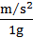 .
- Assume you have a body mass (m) of 70kg and compute the net force the elevator exerts on your feet (F_{E}) for each instance above and record it in column E using the acceleration (a) from column D,
Newton’s Second Law of Motion
, this is the force due to gravity which is your weight
(watch your signs for acceleration!)
Questions:
- (1pt) When the elevator is standing still or at constant velocity (middle of descent/ascent), the accelerometer should read 1g. If it does not, what type of error does this represent?
- (1pt) Explain why the magnitudes of the accelerations at the beginning of the ascent are different from the accelerations in the middle of the ascent.
- (1pt) Explain why the direction of the accelerations at the beginning of the ascent are different from the accelerations at the beginning of the descent.

- (1pt) What was the difference in magnitude between the starting acceleration and the stopping acceleration on the descent? Was it more or less than the difference during the ascent? Why do you think this is so?
- (1pt) Compare how you felt (heavy, light or normal) with the accelerometer readings?
Part II. Centripetal Acceleration with Stand and Spin (group data collection)
Objective – During this lab you will determine centripetal accelerations using a crash test dummy (student volunteer) on the stand-and-spin using a horizontal accelerometer. You will also compute the tangential velocity of the subject using the equation 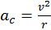.
Discussion:
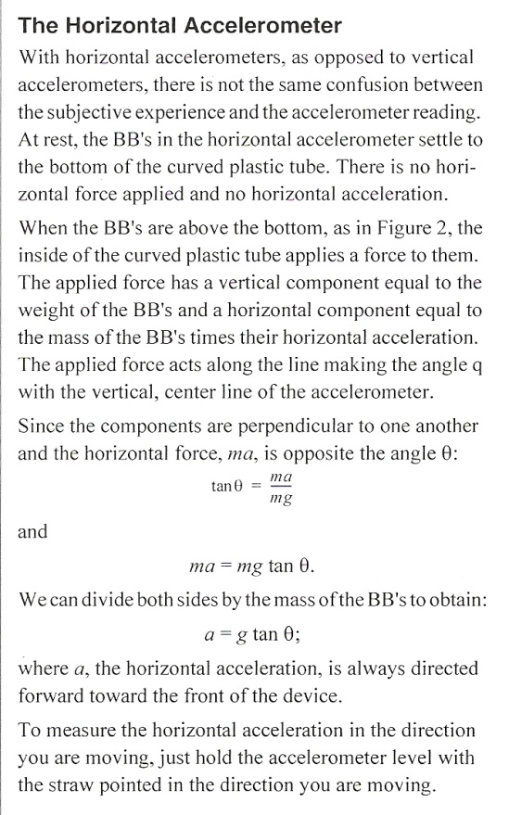 | 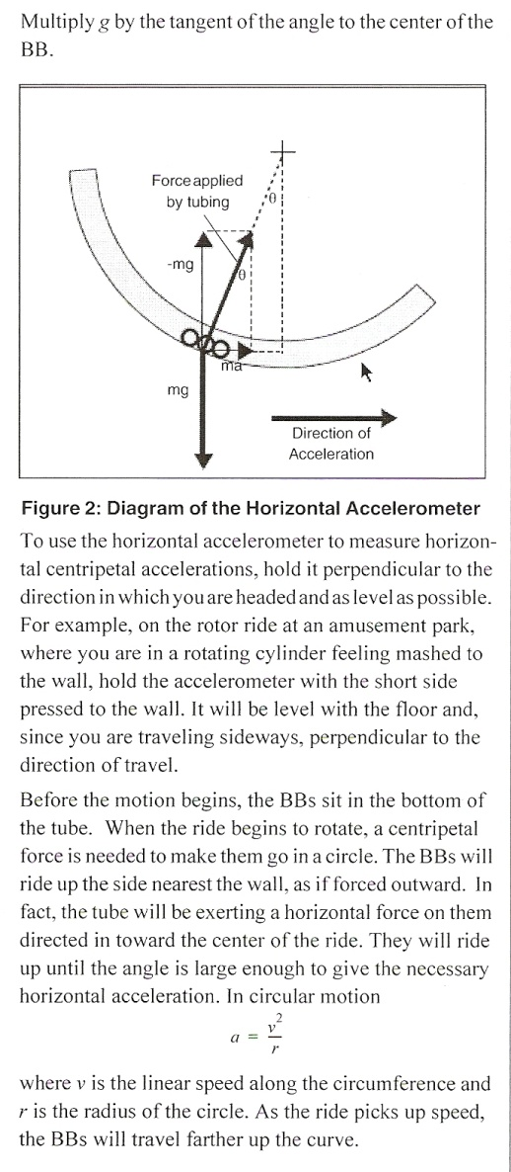
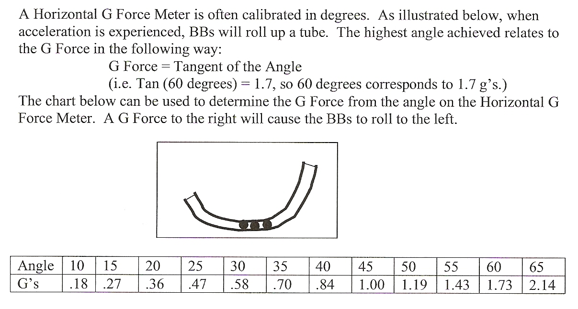

Procedure – You will work in a group to obtain readings. One person volunteers to be the crash dummy, one person takes the measurements, everyone else records the data and laughs at the crash dummy getting dizzy. The person taking measurements and the dummy can obtain data from any of the recorders after the experiment once the nausea passes. Take turns performing each function. (6pts)
- With the dummy standing still, measure the radius from the individual’s centerline to the zero index in the accelerometer with the dummy holding the accelerometer horizontally in one hand with their arm extended. Use meters for the units.
- Measure the radius from the individual’s centerline to the zero index in the accelerometer with the dummy holding the accelerometer with their arm retracted. Use meters for the units.
- With the dummy’s arm extended, spin the dummy at a comfortable pace so that he or she can maintain balance.
- Obtain an angle measurement and announce it to the recorders.
- As soon as the measurement is announced, the dummy retracts their arm and tries to maintain balance.
- Obtain an angle measurement with arm retracted and announce it to the recorders.
 |  | Dummy #1 Name  _____________________ | Dummy #2 Name  _____________________ | Dummy #3 Name  _____________________
RAW DATA | Extended Arm Radius (m)
RAW DATA | Retracted Arm Radius (m)
RAW DATA | Max Accelerometer Angle – Arm Extended (deg)
RAW DATA | Max Accelerometer Angle – Arm Retracted (deg)
COMPUTED DATA | Arm Extended g’s
COMPUTED DATA | Arm Extended a_{c} (m/s²)
COMPUTED DATA | Arm Extended v (m/s)
COMPUTED DATA | Arm Retracted g’s
COMPUTED DATA | Arm Retracted a_{c} (m/s)
COMPUTED DATA | Arm Retracted v
Individual Computations: (Note: do not perform computations until data for all three labs have been taken)
- Complete the following computations for data obtained for arm extended, and then for arm retracted.
- Use the chart above to convert deflection angles into g-forces (use interpolation).
- Convert g-forces into acceleration by multiplying by 9.81 m/s².
- Solve for tangential velocity using the equations, , .
Questions:
- (1pts) If velocity were held constant, what would be the quantitative difference in g-forces when the arm was extended versus when the arm was retracted? Does your data reflect this? Why or why not?
- (1pts) In general, what was the quantitative difference in velocities when the arm was extended versus when the arm was retracted in your data? Explain why.
Part III. Using Horizontal Accelerometer as a Sextant
Objective – During this lab you will determine the height of the ceiling using the horizontal accelerometer as a sextant.
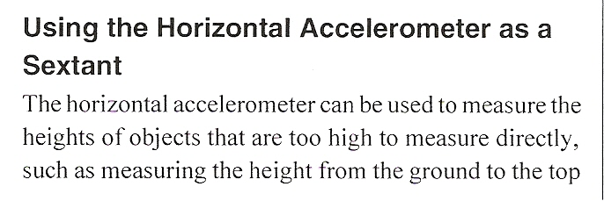  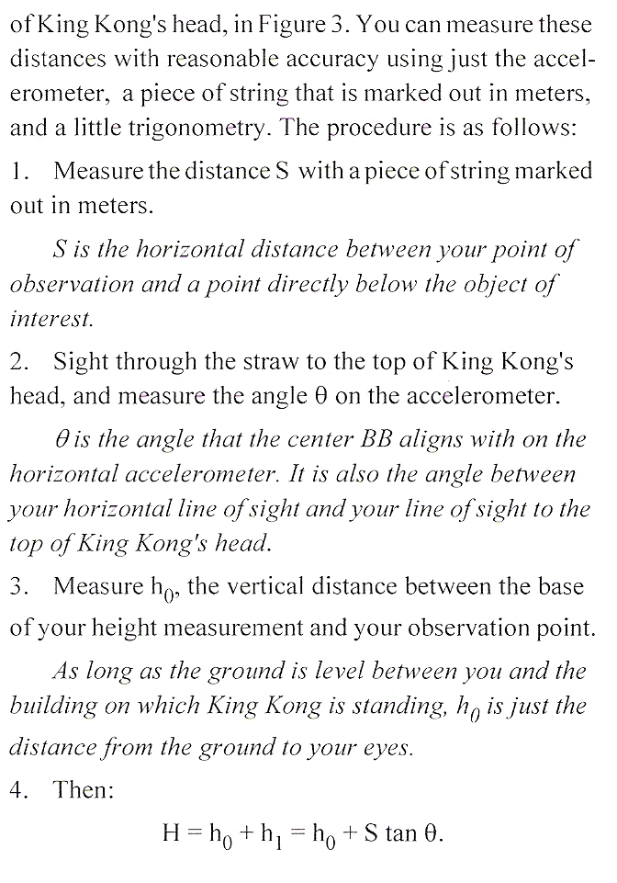 | 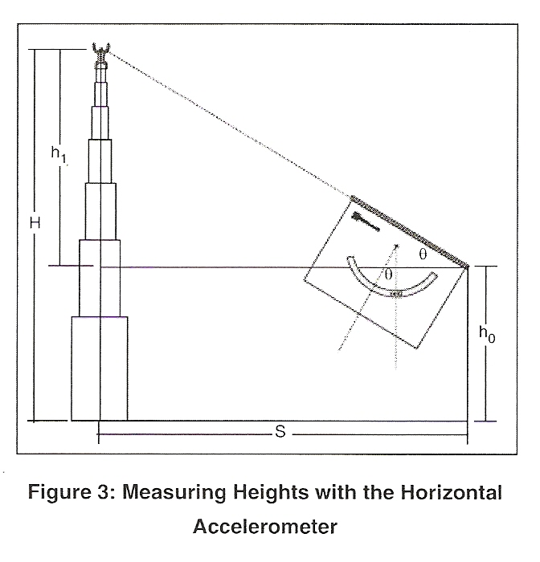
Procedure – This lab is to be done individually. (6pts)

From any position in the room, use the horizontal accelerometer to measure the angle between your line-of-sight and the top of one of the walls. Be sure to measure along a line perpendicular to the wall. | θ =
Have your partner use a ruler to measure the height of your line-of-sight from the ground. | h₀ =
Use the floor tiles to measure your distance to the wall. Each tile is 12” x 12”. | S =
Compute the height of the wall above line-of-sight, | h₁ =
Find the height of the wall, | H =
Measure the actual height of the wall | actual height =
Compute a percent difference between computed value and the actual value 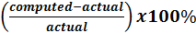 | % difference =

Questions:
- (1pt) What do you think generated the error between your computed value and the actual value?
- (1pt) What type of error is this?

The answers on this lab are a product of my own work and effort. Though I may have received some help in collecting data and understanding the concepts and/or requirements, I did the computational work myself and came up with the answers to all questions on my own.

Student Signature (for electronic submission, type student number in lieu of signature)
Room for improvement
This lab can be improved by:

When complete, E-mail to Mr. Smith @ smithky@pcsb.org
Ensure your filename is “FirstInitialLastNamePerXLabName”

