DevilPhysics
AP Physics

Name: __________________________________

Period: ________ Date: ___________________
Baddest Class on Campus
CONSERVATION OF ENERGY
DATA COLLECTION EXERCISE
The purpose of this exercise is to be able to collect raw data and convert it into a table of meaningful data and a graph related to the principle of conservation of energy.
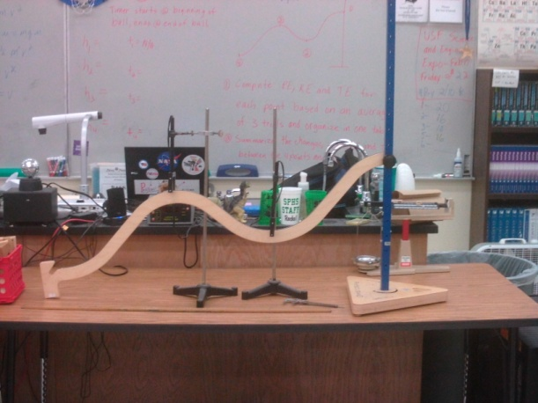
PRE-LAB:
- Use the data collection sheet on the reverse side to record the following data:
C
A
  - Mass of the steel ball (triple beam balance)
D
  - Diameter of the steel ball (calipers
  - Heights above the table at each of the four points along the track (A, B, C, D)
B
  - Adjust photogates to align with ball diameter and center of mass.
LAB PROCEDURE:
- The teacher will perform the experiment in class on the curved ramp.
- Record the time it takes the ball to pass the photogate at each measured point (B, C, D). The teacher will run three trials for each position measured.
- The time measured at each point represents the time it takes the ball to pass the photogate. The distance travelled in that time is the diameter of the ball. The velocity at that point is equal to the diameter of the ball divided by the measured time (watch your units!). Consider this to be an instantaneous velocity measurement.
- Use the data sheet on the reverse to record your processed data. The processed data includes calculations for velocity, kinetic energy (KE), potential energy (PE), and total energy (E) for each of the measuring points using the trial averages of your raw data. In the Supplemental Data section, calculate the change in potential, kinetic and total energy between each two positions by subtracting the energy at the first position from the energy at the second position. Also calculate the total change in potential, kinetic and total energy for the entire course in the same manner. When complete, this data sheet will become an attachment to your final report.
- As a second attachment, create a single graph that shows kinetic energy (KE), potential energy (PE), and total energy (E) for the four track points with a line connecting the data points for the individual energies. Use an X-Y (Scatter) plot with curved connecting lines.
- Type your report using MS Word or other word processor. The report must include:
  - Name, date, period, title
  - Purpose of the lab
  - Brief description of the process used in the experiment
  - Summary of results. Describe and explain the differences between the separate energies at the measured points. Explain any differences between the data and the expected results.
  - Attachments: (1) Raw and processed data sheet, (2) Energy graph.
  - The expectation is that the final report should be no longer than one page single-spaced, but may be longer if needed. The original raw/processed data sheet must be attached along with the graph of your results on a separate page.
- The experiment and raw data collection will be done as a group. However, processing of the data, completion of the graph, and the final report are individual effort.
- The final report and graph must be submitted as a hardcopy.

Raw Data
Mass of Ball |  | g |  | kg
Ball Diameter (d) |  | cm |  | m
Position | Height (m) | Time -1 (s) | Time -2 (s) | Time -3 (s) | Avg Time (s)
A
B
C
D
Processed Data
Position | Potential Energy, mgh (J) | Kinetic Energy, 1/2mv² (J) | Total Energy, PE + KE (J) |  | Velocity, dia/time (m/s²)
A
B
C
D
Supplemental Data
 | ΔPE (J) | ΔKE (J) | ΔTE (J)
A→B
B→C
C→D
Total

