DevilPhysics
AP Physics

Name: _________________________________

Period: ________ Date: ___________________
Baddest Class on Campus
Lab Activity – Momentum (20 Points)
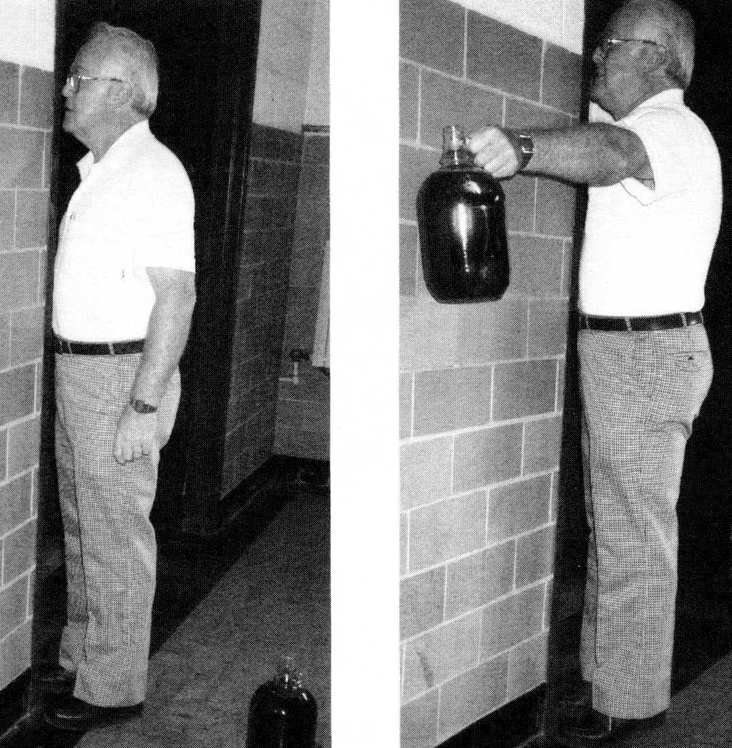
Part 1: Center of Mass (original lab courtesy of Sarah Stanhope, Easley High School)
Procedure A:
- A volunteer stands in an open area where all can see with their hands behind their back. Ask them to stand on their toes. What do you observe?
Answer:
- The volunteer then stands next to a wall with their toes and nose touching the wall and their hands behind their back.
- Ask them to stand on their toes without falling. What happens?
Answer:
Why?
Answer:
- Next ask the volunteer to stand in a doorway or inside room corner so their toes and nose are against the wall. Ask them to hold a textbook in each hand and hold their arms out from their body on either side of the wall. They can move the books backwards or forwards if they want. Ask them to stand on their toes.
What happens?
Answer:
Why?
Answer:
- Should the same amount of weight help people of all heights / weights? Why / why not?
Answer:

Procedure B:

Meter Stick | Distance from Origin
1 | 0 cm
2 | 4.6 cm
3 | 9.9 cm
4 | 16.0 cm
5 | 23.3 cm
6 | 32.3 cm
7 | 43.8 cm
8 | 59.5 cm
9 | 83.5 cm
10 | 132.0 cm

- Obtain 10 meter sticks
- Lay one flat on a table so the 100 cm end is flush with the end of the table.
- Consider the zero end of this meter stick to be the origin.
- Set the second meter stick on top of the first 4.6 cm from the origin.
- Continue stacking the sticks according to the chart at right:
- The formula for center of mass is,
$$x_{cm}=\frac{m_{1}x_{1}+m_{2}x_{2}+m_{3}x_{3}+∙∙∙}{m_{1}+m_{1}+m_{1}+∙∙∙}$$
where x# is the distance from a reference point, here the end of the first meter stick
Consider the mass of each meter stick to be m. All distances are relative to the origin which is the “0” end of the first meter stick, 100cm from the end of the table:
1. What is the center of mass of one meter stick?
Answer:
2. What is the center of mass of the first two meter sticks? (Show work)
Answer:
3. What is the center of mass of all ten meter sticks? (Show work)
Answer:
4. Explain why the sticks don’t fall. (Reference Giancoli, page 182-184)
Answer:

Part 2: Momentum Simulation
Procedure C:
NOTE: For all calculations, assume units are kg, m, and sec.
- Go to the following website http://phet.colorado.edu/en/simulation/collision-lab.
- Click on “Run Now” and maximize the window
- Click “1 Dimension” at the top.
- Drag the green ball all the way to the right and the red ball all the way to the left. Observe the “X” as you move the balls left and right.
- What does the X represent?
Answer:
- Which ball must be more massive? How does the X help you know which ball is more massive?
Answer:
- Why does the X move when you move the balls individually left and right?
Answer:
- Hit Play and Observe the X. Hit Pause when the X changes direction.
- What happened that made the X change direction?
Answer:
- Reset the animation. Click 1 Dimensional again. Click the button that says “More Data”
- Drag the red ball all the way to the left, and the green ball all the way to the right.
- Hit Play, but Hit Pause before the balls collide.
- If you were an observer on the red ball, what would the velocity of green ball be relative to you (include a direction)?
Answer:
- If you were an observer on the green ball, what would the velocity of red ball be relative to you (include a direction)?
Answer:

For all Calculations, Show Your Work. Use the simulation to check yourself.
ALL DATA COLLECTION AND ANALYSIS FOR THIS SECTION IS
INDIVIDUAL EFFORT!!!!

- Reset, select 1 Dimension again, and set the elasticity to 1.00
- Calculate:
The initial momentum of mass 1:
The initial momentum of mass 2:
Total initial momentum:
The initial kinetic energy of mass 1:
The initial kinetic energy of mass 2:
Total initial kinetic energy
- Hit Play, but hit Pause immediately after the collision (don’t allow a ball to hit a wall)
- Calculate:
The final momentum of mass 1:
The final momentum of mass 2:
Total final momentum:
The final kinetic energy of mass 1:
The final kinetic energy of mass 2:
Total final kinetic energy:
- What can you conclude about the momentums and kinetic energies of the system?
Answer:
- What type of collision is this?
- Reset, select 1 Dimension again, and set the elasticity to 0.50
- Since the initial conditions are the same, the initial momentum and kinetic energy are the same as they were calculated in #16 above.
- Hit Play, but hit Pause immediately after the collision (don’t allow a ball to hit a wall)
The final momentum of mass 1:
The final momentum of mass 2:
Total final momentum:
The final kinetic energy of mass 1:
The final kinetic energy of mass 2:
Total final kinetic energy:
- What can you conclude about the momentums and kinetic energies of the system?
- What type of collision is this?
- Reset, select 1 Dimension, and set the elasticity to 0.00
- Since the initial conditions are the same, the initial momentum and kinetic energy are the same as they were calculated in #16 above.
- Hit Play, but hit Pause immediately after the collision (don’t allow a ball to hit a wall)
The final momentum of mass 1:
The final momentum of mass 2:
Total final momentum:
The final kinetic energy of mass 1:
The final kinetic energy of mass 2:
Total final kinetic energy:
- What can you conclude about the momentums and kinetic energies of the system?
- What type of collision is this?
- Make a summary statement for the conservation of momentum and kinetic energy in elastic, somewhat inelastic (50%), and completely inelastic collisions.

Room For Improvement? This lab can be improved by

