Go To: http://phet.colorado.edu/en/simulation/radioactive-dating-game
Purpose: You will use the radioactive decay rate and original-daughter element ratios of carbon-14 and uranium-238 to determine the ages of different objects.
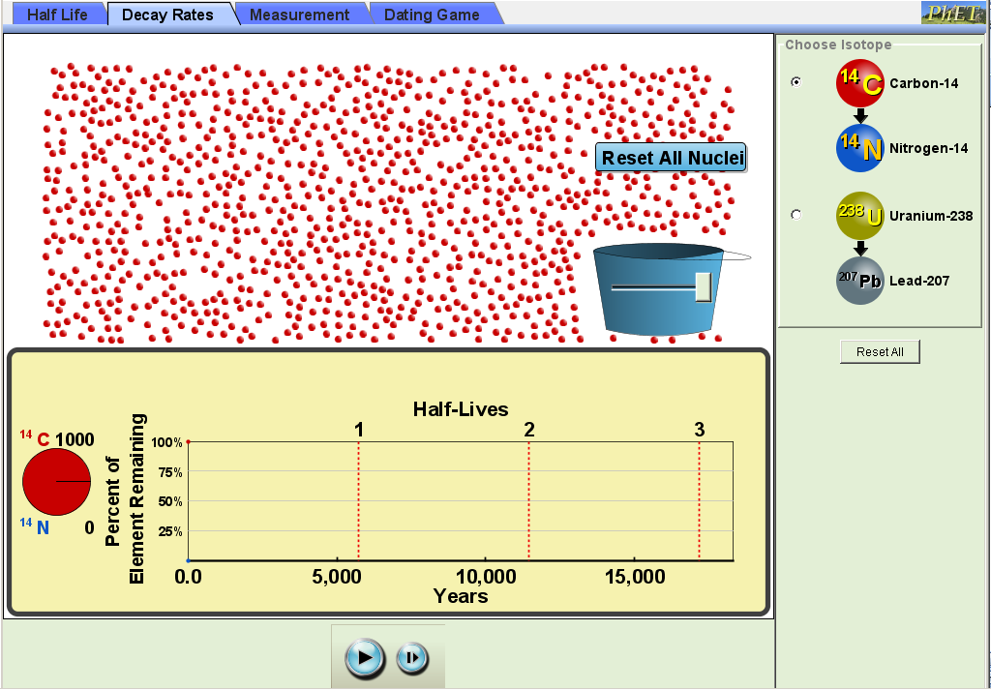
Procedure:
- Load PhET Radioactive Dating Game
- Click on tab for Decay Rates
- (1pt) Select Carbon-14. Using the graph, the estimated half-life for C-14 is ______________________ years.
Bucket Slider
- Move the bucket slider all the way to the right. This will place 1000 C-14 atoms onto the screen.
  - (1pt) Click on the Start/Stop to stop the C-14 decay as you get close to one half-life. Use the Step button to advance the decay to one half-life.
Step
button
Start/Stop
button
    - After 1 half-life, how many C-14 atoms of the 1000 original remain? (use the simulator, don’t just write down half of the original) __________________
  - (1pt) Use the Start/Stop and Step buttons to reach two half-lives. After two half-lives, how many undecayed C-14 atoms remain?
    - Calculate the percent of original undecayed C-14 atoms present after 2 half-lives?
  - (1pt) Use the Start/Stop and Step buttons to reach three half-lives. After three half-lives, how many undecayed C-14 atoms remain?
    - Calculate the percent of original undecayed C-14 atoms present after 3 half-lives?
  - (2pts) Repeat Steps (a) to (d) with uranium-238.
    - Estimated half-life for U-238 is years.
    - After 1 half-life, how many U-238 atoms of the 1000 original remain?
    - Calculate the percent of original undecayed C-14 atoms present after 2 half-lives?
    - Calculate the percent of original undecayed C-14 atoms present after 3 half-lives?
  - (1pt) Based on the results of 4a to 4d, explain the meaning of the word “half-life” in one sentence.

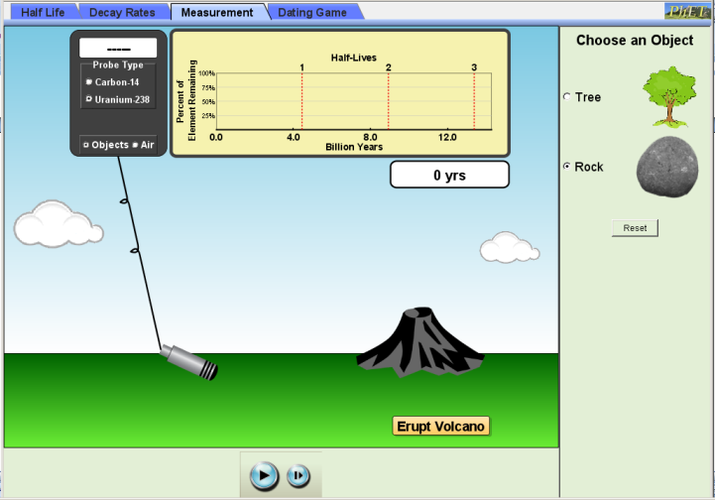
- Click on the Measurement tab.
- Under Probe Type, select Uranium-238 and Objects. Under Choose an Object, select Rock.
- (1pt) Click on Erupt Volcano. Let the simulation run until you reach 1 half-life. What % of the original uranium remains? . How many years did this take?
- Under Probe Type, select Carbon-14 and Objects. Under Choose an Object, select Tree.
- (1pt) Click on Plant Tree. Let the simulation run until you reach 1 half-life. What % of the original carbon remains? . How many years did this take?
- (2pts) Explain why uranium-238 is used to measure the age of rocks while carbon-14 is used to measure the age of the tree trunk?

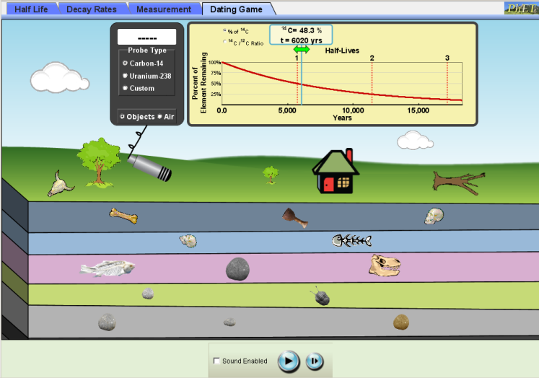
- Click on Dating Game tab. There are objects on the surface and in the five layers containing rocks and fossils beneath the surface.
- Select the Carbon-14 detector. Move the Geiger counter to each fossil and record the % of original in the table below
- Based on the percent of original, make a guess as to the age of the object and record it.
- On the ½ life graph, move the green arrow right or left until the % of original matches the reading on the detector. Record the estimated age for each fossil in the table.
- Repeat Steps 12 and 13 using the Uranium-238 detector to estimate the rock ages. For objects with no remaining C-14 or U-238 radiation, use the custom setting to estimate ages. Select different half-lives until you reach the one with the least percent remaining.
- (2pts) Using what you have learned in this activity, summarize how you can use radioactive decay to determine the ages of objects.

Table: Radiometric Ages for Various Objects (9pts)

Object | Measured using C-14, U-238 or Custom Setting? | % of Original | Measured Age
Animal Skull
Close Living Tree
Distant Living Tree
House
Dead Tree
Bone
Wooden Cup
1st human skull
2nd human skull
Fish Bones
Fish Fossil 1
Rock 1
Dinosaur Skull
Rock 2
Trilobite
Rock 3
Rock 4
Rock 5

Room for improvement
IMPROVEMENT: This lab can be improved by:

When complete, upload to Focus. Ensure your filename is “FirstInitialLastNamePerXLabName”

